*EXPERIMENT No. :- 5 Design an Automatic Night Lamp*.

*CIRCUIT DIAGRAM:* 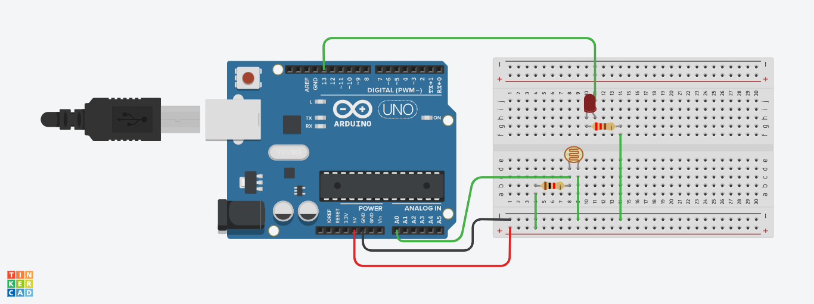

*THEORY:*

*Concepts Used :*

Here we used the concepts of LDR, i.e. Light Dependent Resistor.

An [LDR](https://kitronik.co.uk/components/switches-and-sensors/light-sensors.html) is a component that has a (variable) resistance that changes with the light intensity that falls upon it. This allows them to be used in light sensing circuits.

The most common type of LDR has a resistance that falls with an increase in the light intensity falling upon the device and increases with decrease in light intensity.

*Learning And Observations:*

We learned how to use an LDR. We used it to make an automatic lamp which will glow in night and not glow when it is light . Here we were also introduced to the Analog pin of the Arduino board. We observed that when we cover the LDR with our hands to prevent light falling on it , the led glows and when we remove our hand from the sensor , the led stops glowing .

*Problems And Troubleshooting :*

The problem encountered by me was that the connections were loose due to which the system was not working . The problem was solved by fixing the connections.

*Precautions:*

1. The led should always be connected to arduino via a resistor to prevent it from damage.
2. Check for whether the wires are continuous or not using a multimeter.
3. The connections should be tight and not loose.
4. The cathode and anode should be connected to their respective ports.

*Learning Outcomes:*

I learned the basic working principle of an LDR , its working , and its applications. I learned how to connect it with arduino and design an automatic night lamp.